Introduction
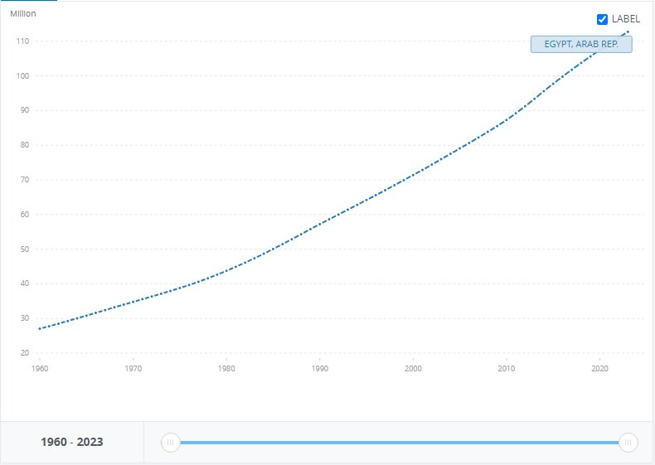
Egypt endures from 11 grand challenges. The most concerning of which are urban congestion and population growth. The first of the two is population growth. A threatening problem that Egypt faces because it consumes most of the country's resources. Population in Egypt reaches as high as 106,890,565, according to the Central Agency for Public Mobilization and Statistics (CAPMAS). 19 million of which are condensed in the Greater Cairo Metropolitan Area (GCMA). As illustrated in Figure (1), the population went from 27M to 112M in 63 years with a 314% increase in population and 2% growth a year with Birth numbers exceeding deaths’ which makes Egypt more and more crowded second by second. As a result, more than 106 million people live on the same space, resources, food, and national income while most of them don’t work because of high unemployment and lack of job opportunities.
Fig. 1 Rate of Egypt's population growth
Secondly, Urban congestion, mostly a result of the previous grand challenge, population growth, is the reason behind a multitude of problems like traffic congestion, due to the large amounts of people that travel in a small area, disease breakouts, as diseases are more infectious in largely populated areas, and overuse of infrastructure and public sectors.
For the solutions already tried, the chosen two bridges are Tower Bridge and Hawthorne bridge. Tower Bridge is a bascule bridge operated with a hydraulic system. One of the strength points of this bridge is its efficiency as it is significant in London transportation because it carries 40,000 people and 21,000 vehicles. It opens 800-1,000 times per year to allow for the marine traffic to pass. However, the bridge can’t bear earthquakes. As it has Sensitivity to vibrations. When the bridge bascules open, they're subject to vibrations and oscillations. Over time, this can cause wear and tears. The second prior solution is Hawthorne bridge. Hawthorne Bridge is a vertical lift bridge. From the points of strengths of the bridge Transportation Importance: Hawthorne Bridge continues to serve as an important transportation route between downtown Portland and the South Waterfront neighborhood, which provides important access to various businesses, residences, and other important venues. Yet, the bridge remained intact after said modifications. From the points of weakness of the bridge is Earthquake Vulnerability According to Washington County, Portland metropolitan area has experienced six earthquakes of 5.0 magnitude or greater, which flags Portland as earthquake-prone region. Since Hawthorne Bridge is an old structure, it may be more susceptible to damage in the event of a major earthquake.
The solution that has been chosen is a bridge. The truss type used in it is Warren truss with verticals as it is efficient for short spans, and it distributes the force equally on the members because it consists of equilateral triangles. The opening mechanism of the bridge is a hydraulic bascule. The machinery ensures that the bridge travels upwards and the counterweights downwards. This ensures that everything is balanced during the vertical movement. Hydraulic bridges provide smooth and accurate acceleration and deceleration.

.

